# [AI-related FYP] AI for Personalized Content Recommendations

Prof Ruohan Zhan

## Names of Participants:

CHENG, Yan Hei (Cathy)

WAN, Nga Chi (GiGi)

CHAN, Tony Yuen Yeung (Tony)

## Project Summary

### i) What is the problem?

The primary challenge in building a useful content recommendation system (CR) is effectively capturing and adapting to user preferences in dynamic environments. This challenge is compounded by issues such as data sparsity, which arises from limited user-item interactions, and the cold-start problem for new users and items. Additionally, scalability is crucial for processing large datasets and delivering timely recommendations. This project focuses on studying various techniques and models in CR systems to discover solutions for these common issues, ultimately aiming to enhance the effectiveness and user satisfaction of recommendation systems.

### ii) How do you hope to solve it?

1. **Study Different CR Techniques/Models**:

* Conduct a comprehensive literature review of existing CR techniques, including collaborative filtering, content-based filtering, and hybrid approaches.
* Investigate temporal dynamics in recommendations to understand how user preferences change over time.

1. **Research Common Issues in CR Systems**:

* Identify prevalent challenges in CR systems, such as the cold-start problem, scalability, and user satisfaction.
* Explore industrial approaches to address these issues, focusing on effective solutions.

1. **Build an Interactive CR System**:

* Backend: Develop a system that processes user requests (queries) and applies various CR models based on user interactions and preferences.
* Frontend: Create a user-friendly interface that stores cookies and allows users to interact seamlessly with the system.

1. **Incorporate Extra Features**:

* Integrate additional functionalities such as sentiment analysis and large language model (LLM) extraction to enhance the recommendation process.

1. **Evaluate the Performance of the CR System**:

* Gather user feedback through user acceptance testing (UAT) and conduct simulations to assess the system's performance.
* Measure key performance metrics, including precision and recall, to evaluate the effectiveness of recommendations.

1. **Review and Adjust Techniques/Models**:

* Analyze the performance results and adjust the models, parameters, and structures based on user feedback and simulation outcomes.

### iii) What result do you expect to achieve? (A time schedule should also be provided)

1. **Interactive CR System**:

* A fully functional CR system that effectively processes user queries and provides relevant recommendations.
* Backend: Capable of applying different models based on user input.
* Frontend: User interface that enhances user interaction and experience.

1. **Research Paper**:

* Existing Techniques/Models: A comprehensive overview of popular industrial approaches to CR techniques and models studied in the project.
* Common Issues/Problems: Identification of general issues encountered in CR systems and the proposed solutions, along with limitations of the approaches.
* Performance Evaluation: Detailed analysis of UAT results, comparing performance metrics (precision and recall) across different stages to demonstrate improvements.
* Limitations and Future Research Directions: Discussion of the project's limitations and suggestions for future research avenues.

1. **Project Video**:

* Provide a brief overview of the content recommendation system (CR) project, highlighting its key objectives and significance in enhancing user experiences.
* Showcase the interactive CR system in action, demonstrating how it processes user queries to generate personalized recommendations.

### iv) What is important about your expected result?

1. **Relevance of Recommendations**: The CR system should be able to return relevant search results based on user keywords and feedback, enhancing user satisfaction and engagement.
2. **Performance and Diversity of Techniques/Models**:

* Basic CR Models (60%): Implement foundational models such as Matrix Completion and Collaborative Filtering.
* Machine Learning Techniques (30%): Incorporate advanced techniques like embeddings to improve recommendation quality.
* Additional Techniques (10%): Utilize extra techniques such as LLMs to enhance the system's capabilities.

1. **Delivery of the Whole Project**: The successful execution of the project will be evaluated at each stage, focusing on:

* Data Pre-Processing:
  + Identify key features and insights from the dataset.
  + Clean, standardize, and embed the data for effective processing.
* CR System Functionality:
  + Implement a structured retrieval process: Retrieval => Pre-Ranking => Ranking => Re-Ranking.
* User Experience: Ensure the functionality and UI/UX of the interactive CR system are intuitive and user-friendly.

### Project Timeline:

|  |  |  |  |
| --- | --- | --- | --- |
| **Task** | **Duration** | **Expect End Date** | **Status** |
| Study the Background of CR | 3 months | 17/11 | Completed |
| ~~Study and Select the Dataset~~ | ~~2 months~~ | ~~17/11~~ | Adjusted |
| Research on System Setup | 1 month | 17/11 | Completed |
| ~~Data Pre-Processing~~ | ~~2 weeks~~ | ~~31/11~~ | Removed |
| 1st Stage BE (Retrieval) | 1 month | 31/12 | In Progress |
| 2nd Stage BE (Pre-Ranking + Ranking) | 1 month | 31/1 | / |
| 1st Stage FE (Draft for UAT) | 1 month | 31/1 | / |
| 1st UAT + 3rd Stage BE (Revamp + Re-Ranking) | 1 month | 28/2 | / |
| 2nd Stage FE (80%) | 1 month | 28/2 | / |
| Final Report (1st half) | 2 weeks | 16/3 | / |
| 2nd UAT + 4th Stage BE (Revamp + Other Features) | 1 month | 31/3 | / |
| Final Report (2nd half) | 2 weeks | 6/4 | / |
| 3rd UAT (Final Evaluation) | 2 weeks | 13/4 | / |
| 3rd Stage FE (Finalize) | 2 weeks | 13/4 | / |
| Video Production | 1 month | 30/4 (TBC) | / |

#### Task Update:

1. **Study the Background of CR (Completed)**

* Completed an initial review of retrieval models, including User/Item Collaborative Filtering, Deep Structured Semantic Model (DSSM), and Deep Retrieval according to a [tutorial](https://github.com/wangshusen/RecommenderSystem) of Red Recommendation System.
* Will continue exploring models addressing specific challenges and documenting pain points as part of further research.

1. **Study and Select the Dataset (Adjusted)**

* Currently using the [Yelp Dataset](https://www.yelp.com/dataset) for learning and testing.
* Open to exploring additional datasets that might align better with project goals.

1. **Research on System Setup (Completed)**

* Modelling: *Python* (using *TensorFlow* & *Scikit-learn*; may expand).
* Backend: *Python* (*Flask* for API and real-time processing).
* Frontend: *React* (default *Flask* pages used temporarily).
* Database: *SQLite* (considering *Redis* or *Milvus* for vector-based queries).
* Hosting: Linux machine provided by the department (exploring *AWS*/*Azure* as alternatives).

1. **Data Pre-Processing (Removed)**  
   Pre-processing will depend on the selected models. This task has been deferred to allow flexibility.
2. **1st Stage BE (Retrieval) (In Progress)**

* Implemented a draft ***Item Collaborative Filtering*** (***Item CF***) system using Flask.
* Currently working on the ***Deep Structured Semantic Model*** (***DSSM***).
* Planned Retrieval Models:  
  (1) **Item CF**, (2) **User CF**, (3) **DSSM**, (4) **Deep Retrieval**/**Tree-based Deep Model** (**TDM**), (5) **GeoHash** and other simple retrieval models.

### Additional Updates:

1. Task Management: [Trello](https://trello.com/b/5JG6Hmrf/milestones-tasks) for project tracking.
2. Ideation & Visualization: [Miro](https://miro.com/app/board/uXjVKgJsXMs=/) for brainstorming, planning, and visualization.
3. GitHub Repository: [Content Recommendation Project](https://github.com/tonyctyy/content-recommendation)

Visualizations and updates are shared on Miro. Feedback & suggestions are welcome!

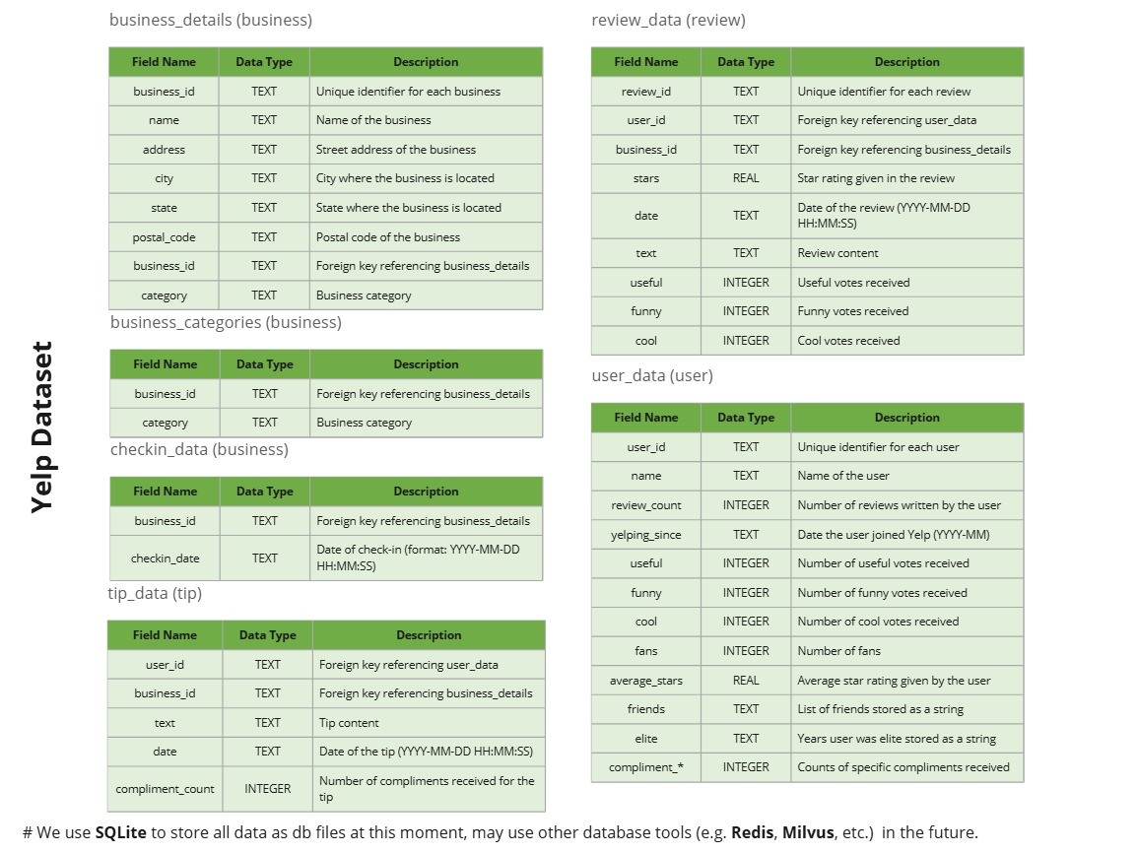

## The Author List

Name(s) of the report writer(s). (For multiple writers, indicate sections and/or percentages done by each.)

|  |  |
| --- | --- |
| **Section** | **Participant** |
| i) What is the problem? | Cathy |
| ii) How do you hope to solve it? | Cathy (50%), Tony (50%) |
| iii) What result do you expect to achieve? (A time schedule should also be provided) | GiGi (50%), Tony (50%) |
| iv) What is important about your expected result? | GiGi |